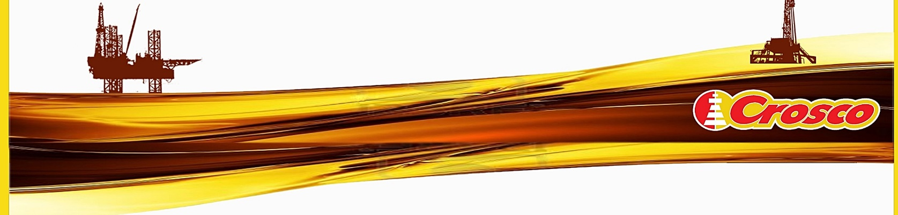ENERGY MANAGEMENT POLICY

CROSCO, Integrated Drilling & Well Services Company, Ltd. (hereinafter referred to as the Company) is a leading company in the business of providing drilling, workover and well services in Croatia. As service activities in the exploration and production of oil, gas and water are extremely energy-intensive processes, our fundamental commitment is corporate social responsibility through educement of the impact on the environment and continuous improvement of energy management system.

Responsible use of energy and continuous monitoring and improvement of the energy performance are the key role in the business and management of our processes:

1. Improving the energy performance through the development and implementation of best business practices, and
2. The economic design of new rigs and buildings with high energy efficiency.

To achieve the goal of sustainable energy management system, the management structure of the Company has a leading role in promotion, development, and application of the following principles of energy management:

* In the long term, we are committed to develop and maintain energy system in the way of continuous improvement and learning by using new, more energy-efficient technologies, processes, tools and equipment.
* We are developing energy awareness and energy acceptable behavior and culture in which the best business practice will be created, exchanged, and freely adopted, including the possibility of internal and external education and the implementation of employees' innovative proposals in order to improve energy performance.
* We ensure development and implementation of energy projects aimed at reducing energy losses, greenhouse gas emissions and environmental impact by aligning this system with other management systems in our companies.
* We carefully follow all requirements related to energy efficiency, energy consumption and greenhouse gas emissions and ensure compliance with applicable statutory and other requirements which the Company committed itself to.
* We provide transparency and availability of data and resources for the achievement of general and specific objectives, internally publish the established objectives, information on the results achieved; we conduct an internal evaluation of energy management and provide feedback to the management and employees.
* We use internal and external benchmarks to identify opportunities for improvement.
* We maintain communication in the management of energy resources.
* We cooperate and share our experience in energy management with all INA Group companies.

Adherence to the principles of this Policy is the responsibility of all our employees and contracting partners. This Policy is available to all interested parties.

|  |  |
| --- | --- |
| Zagreb, May 2025. | Company Director |
|  | Gábor Darab |